New AAMC clinic targets underinsured

Officials: 10,000 patients will be served in first year
By SHANTEE WOODARDS, Staff Writer
Capital Gazette Communications
Published 10/13/10

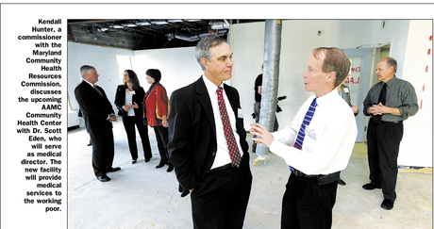

Shannon Lee Zirkle — The Capital
Kendall Hunter, a commissioner with the Maryland Community Health Resources Commission, discusses the upcoming AAMC Community Health Center with Dr. Scott Eden, who will serve as medical director. The new facility will provide medical services to the working poor.

Nestled behind a veterans center and a hair salon on Forest Drive, a new health center for the working poor is coming to Annapolis. Officials from Anne Arundel Health System yesterday announced the creation of the AAMC Community Health Center, which will provide low-cost medical services for patients who meet income requirements. Anne Arundel Health System, the parent company of Anne Arundel Medical Center, received a $150,000 state grant to operate the new facility, which is expected to open early next year.
The community health center will be part of the health system's Vision 2020, which focuses on wellness for individuals and the community, said Victoria W. Bayless, AAHS president and chief operating officer.
"We're really here to provide a community health center for those that don't have the same access to health care like the rest of us do," Bayless told state and community leaders gathered at the site. "We hope it can be a model for others in our region."
The Maryland Community Health Resources Commission awarded the three-year grant to the center, which is among 78 clinics the agency is assisting statewide. Of those clinics, 22 are designed specifically to expand access to primary care. The Annapolis facility is expected to have 10,000 patients in its first year and to serve 60,000 patients over a five-year period.
Dr. Scott Eden will be the center's medical director and will work there with two other providers. More than 20 years ago, a similar practice he operated with three nurse practitioners had to shut down because it wasn't making money. The new clinic will have grant funding and will be supported by the hospital as long as it breaks even, Eden said.
"If it's not a black hole (of finances) we're committed to making more," Eden said. "It doesn't resolve the access issues for Anne Arundel County, but we can serve (the underinsured who) … live in Anne Arundel County."
Federal health reforms are trying to steer patients away from emergency rooms and toward regular checkups and treatment from their physicians. But even with that on the horizon, there is a need for greater access to routine care, officials said.
By offering primary care, the health center will eventually save the system money, said Rep. John P. Sarbanes, D-Baltimore. "It's better for the patients … This allows patients to become full partners in their own care."
The new facility will be operated as a "patient-centered medical home" where health care providers coordinate comprehensive care throughout a patient's lifetime. The center will be tied in with AAHS' electronic medical records system, so clinic patients can also go to AAMC and have their medical history accessed there.
The AAMC Annapolis Outreach Center already operates within the Stanton Community Center. The free clinic provides medical and dental care to roughly 6,500 patients annually.
The new clinic- at Forest and Gemini drives - will provide services to patients who are underinsured but have some ability to pay, officials said. The services will cost at least $25, and financial advisers will help patients locate any assistance they can get based on their income. The staff will speak both Spanish and English.
Frances B. Phillips, deputy secretary for the state Department of Health and Human Services, said more such facilities are needed. She said Eden approached her a few years ago with this concept, and she is pleased to see it coming to fruition.
"He saw an outbreak of the underserved and sought to offer them services," Phillips said.

